**Summer family rowing/water activities camp at Hardwick Sat & Sun 1 & 2 September**

Come and join us for a weekend of water activities with an overnight camp at the Hardwick campsite (just downstream of our site)

[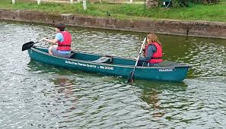](https://www.google.co.uk/imgres?imgurl=https://www.visitdevon.co.uk/imageresizer/?image%3D/dmsimgs/DSC_0298_694675825.jpg%26action%3DProductDetail&imgrefurl=https://www.visitdevon.co.uk/things-to-do/devon-canoe-and-rowing-boat-hire-p2297503&docid=XsnxKNf9zJm1hM&tbnid=R5g5aUgxKeQeJM:&vet=10ahUKEwjPgoyOj4rbAhWOW8AKHRowD9EQMwiYAihCMEI..i&w=750&h=430&bih=876&biw=1280&q=rowing%20boat&ved=0ahUKEwjPgoyOj4rbAhWOW8AKHRowD9EQMwiYAihCMEI&iact=mrc&uact=8)[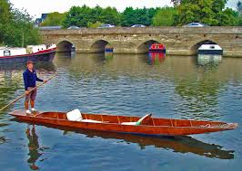](https://www.google.co.uk/imgres?imgurl=https://www.avon-boating.co.uk/files/image/Small%20Boat%20pics/1.jpg&imgrefurl=https://www.avon-boating.co.uk/small-boat-hire/rowing-boats&docid=JiH032a7yst_jM&tbnid=ydugSG_3G2ccAM:&vet=10ahUKEwjPgoyOj4rbAhWOW8AKHRowD9EQMwivAihZMFk..i&w=1602&h=1139&bih=876&biw=1280&q=rowing%20boat&ved=0ahUKEwjPgoyOj4rbAhWOW8AKHRowD9EQMwivAihZMFk&iact=mrc&uact=8)[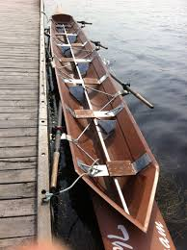](https://www.google.co.uk/imgres?imgurl=https://learntorowstjohns.files.wordpress.com/2012/09/boat1.jpg&imgrefurl=https://fixedseatrowing.com/getting-started/crew-composition/boat-2/&docid=vCAVNN9f6lCdGM&tbnid=EARoQZhPMA_RBM:&vet=12ahUKEwjfrfiRkIrbAhUJLcAKHRS0AKE4rAIQMygeMB56BAgBEB8..i&w=1936&h=2592&bih=876&biw=1280&q=rowing%20boat&ved=2ahUKEwjfrfiRkIrbAhUJLcAKHRS0AKE4rAIQMygeMB56BAgBEB8&iact=mrc&uact=8)[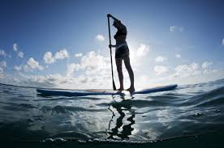](https://www.google.co.uk/imgres?imgurl=http://cdn.triathlete.com/wp-content/uploads/2014/09/shutterstock_105558221-634x421.jpg&imgrefurl=http://www.triathlete.com/2014/09/training/stand-paddleboarding-sup-can-benefit-triathlon-training_105266&docid=9JpuxK_uf4ZLNM&tbnid=q43-XEMVAJ8XWM:&vet=10ahUKEwjomYXFkIrbAhVOQMAKHXXaCeMQMwi3AigfMB8..i&w=634&h=421&bih=876&biw=1280&q=paddleboarding&ved=0ahUKEwjomYXFkIrbAhVOQMAKHXXaCeMQMwi3AigfMB8&iact=mrc&uact=8)

The weekend programme is being planned and is likely to include:

Sat mid morning Arrival at site and set up camp

Lunch

Afternoon a variety of activities will be on offer including stand up paddle boarding, Canadian canoes, punting and of course rowing. Later in the afternoon we may be able to arrange a foraging or orienteering expedition in the woods above the Hardwick estate

Sunday morning further opportunities to try out water activities

We will break camp and finish around lunchtime.

Please make a note of the dates and if you are interested in participating do let me know. Come along as an individual or bring your family /friends. And if you would like to help with the arrangements by offering to cox, coach, cook or just general help I would be delighted to hear from you.

[ros.crowder@btinternet.com](mailto:ros.crowder@btinternet.com) or 07981 516009